**ADDITION OF N NUMBERS**

**AIM:** To compute addition of N numbers using 8085 processor.

**ALGORITHM:**

1. Load the base address of the array in HL register pair.
2. Load the memory with data to be added.
3. Take it as count.
4. Initialize the accumulator with 00.
5. Add content of accumulator with content of memory.
6. Decrement count.
7. Load count value to memory location.
8. Repeat step 5.
9. Check whether count has become 0.
10. Halt.

**PROGRAM:**

LXI H,8000

MOV C,M

MVI A,00

MOV B,A

LOOP: ADD C

JNC SKIP

INR B

SKIP: DCR C

JNZ LOOP

LXI H,8007

MOV M,A

INX H

MOV M,B

HLT

**OUTPUT:**

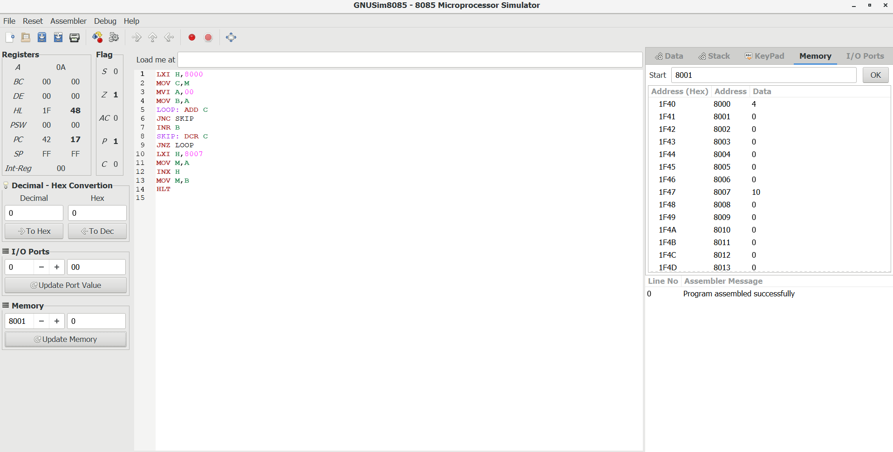

**RESULT:** Thus the program was executed successfully using 8085 processor simulator.